A- Purpose and Scope
This document describes the procedures established for making a collection or biological samples available at CeRBiM.

The provision of biological resources is subject to different formalities depending on the circumstances; a distinction is made between: :
- x Release: CeRBiM provides the investigator or their representative with the biological resources that were entrusted to CeRBiM for the preparation and storage of biological resources during the reservation period. The operations team completes the release request, specifying the number, type, and quantity of the requested samples, as well as the associated data.CeRBiM then removes the samples from inventory. It is specified that any removal is final.
- Transfer: CeRBiM transfers the biological resource to an external third party. During the reservation period, this transfer is possible only if the investigator agrees to it and the CeRBiM Director or a designated representative approves it. Furthermore, the transfer requires authorization from the ministry.

- Export: This refers to a sale to a customer located outside of France. -

Applications for authorization are submitted to the relevant authorities by the CeRBiM Regulatory Liaison Officer (DRCI).

B- Reference Documents (Standards)
NF EN ISO 20387 Standard: General Requirements for Biobanking
ISO 9001 Standard: Quality Management Systems—Requirements

C- Responsibilities
The CeRBiM Manager is responsible for implementing this procedure.
The Quality Coordinator ensures that the document is kept up to date in collaboration with the operations team.

D- Instruction Description

Biological resources are stored in a conservation area accessible only to authorized personnel before being handed over to the carrier or applicant.

D-1 Flowchart

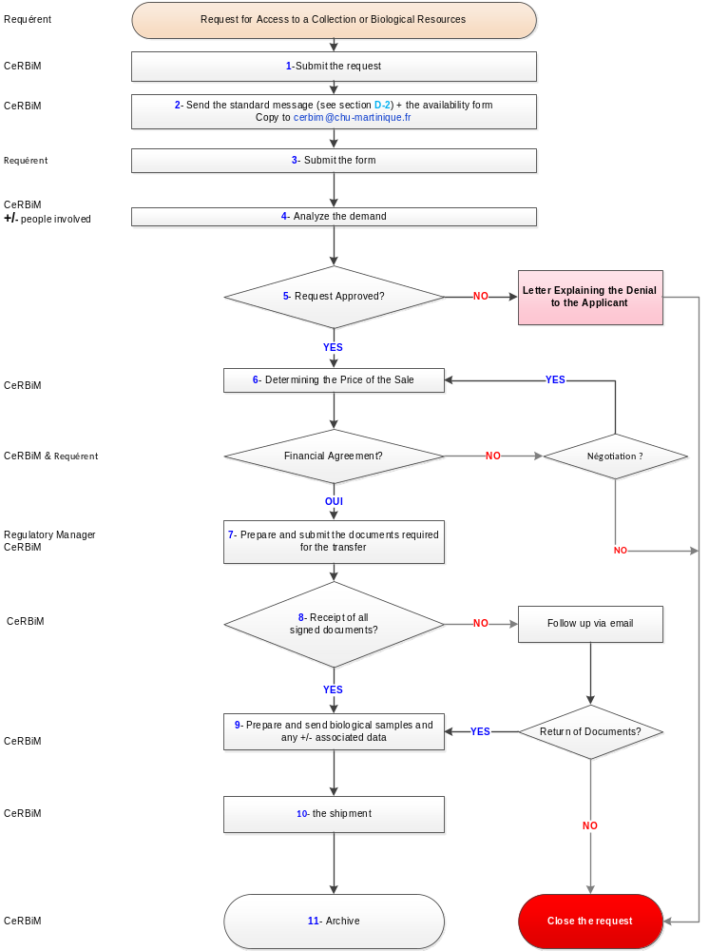

D-2 Standard response message to the requester and cerbim@chu-martinique.fr :

We acknowledge receipt of your request, reference number xx-YYYY.

Attached is the availability form, which you must complete and return to us so that we can verify that all requirements have been met.

(Availability form attached)

E- Related Documents
- via Kalilab

